[](http://www.google.co.uk/imgres?imgurl=http://www.nao.org.uk/graduateblog/wp-content/uploads/sites/19/2014/11/goodbye2.jpg&imgrefurl=http://www.nao.org.uk/graduateblog/2014/11/28/time-to-say-goodbye-what-i-will-miss-most-about-the-nao/&h=255&w=648&tbnid=dYEW8nd5NREgGM:&zoom=1&docid=LScreAaSGUIYjM&ei=1MmkVcaPJ4TC7gb4wpXgCw&tbm=isch&ved=0CD8QMygYMBhqFQoTCMbJw8Wb2sYCFQSh2wodeGEFvA)

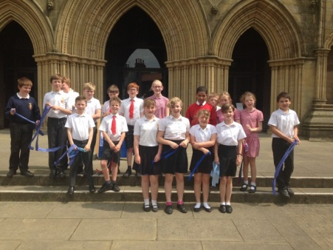

We would like to extend a warm welcome to Shylah Ben-Moussa who has joined our school. Shylah has recently moved to the area from Crewe and is in Year 1. We hope she settles quickly and make lots of new friends.

As always the end of the summer term is a sad time as we say goodbye to pupils and governors We have eight Y6 pupils leaving us today; Jack Burke is going to Richmond School; Zoe Farren-Ross, Jessica Smith and Luke Taylor are going to Bedale High; Megan Gotts and Tyler Gotts are going to SFX and Isaac Wood and Fred Cooper are going to Ripon Grammar. Danielle Smith also leaves us to move to Catterick Village. We wish them the very best of luck in their new schools and hope they will keep in touch. We also say goodbye today to Liz Bentley who until February had been our Chair of Governors for over five years. Over a period of eight years on the governing body Liz has worked tirelessly for the children in our school and she has played a significant role in improving the effectiveness of the governing body and helping us to become a ‘Good’ school. We will miss her greatly as a governor and we are exceedingly grateful for everything she has done; however she is keen to remain involved in the life of the school and we will always be pleased to see her at any-time.

Headteacher End of Year Report

Much has happened over the last year in the life of the school which have all contributed to the very positive future that lies ahead. In the Autumn term we had a very successful church inspection which judged us to be a good church school across all areas. In January we collaborated with Burneston school and this has created good opportunities for staff to work together and view each others’ practice. Similarly children have attended lots of sporting ventures and other visits together and have enjoyed the chance to mix. During the next academic year the development of the collaboration will be one of our main priorities and we will aim to create much closer links between the two schools. A few weeks ago Burneston received a full Ofsted inspection which judged them to be a ‘Good’ school – both schools are now ‘good’ and this places us in a much stronger position to create lots of opportunities for working together, and much has already been planned. Finally we end the year on two high notes. Firstly our KS2 SATs scores were strong and results were above the national average in reading, writing, maths and spelling, grammar and punctuation. Secondly we have recently announced that we will be returning to three classes from September. The smaller classes and narrowing of year groups as well as new staff and the reorganisation of the expertise within the school creates exciting times for us. Burneston school will also have the same class structure next year, thus furthering opportunities to work together and share good practice. There is no doubting the many successes we have enjoyed this year and we will use these as a platform for driving our school forwards in 2015-16.

Leavers Service

On Wednesday 1st of July, the year 6’s from both schools, Aiskew and Burneston went to Ripon Catherdral where we celebrated ‘moving on’. During our time there we sang hymns and took part in a variety of stories and tips for moving on. All the year 6’s really enjoyed our time there even though it was thundering outside.

By Jack and Issac

Lost Property

We have a blue adult hoodie which was left in school following Aiskew’s Got Talent. If this is yours please see Mrs Armstrong.

War Memorial Trust Workshop

A lady called Ruth came in to talk to us

about War Memorials and how to look after them. She showed us some before and after pictures of some extremely damaged memorials. We did a test to see if our memorial needs help.

By Kayleigh McTavey & Katie Kettlewell

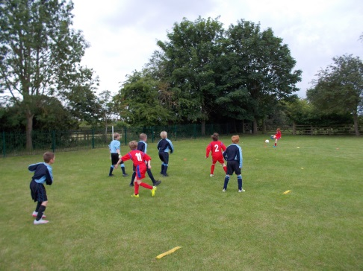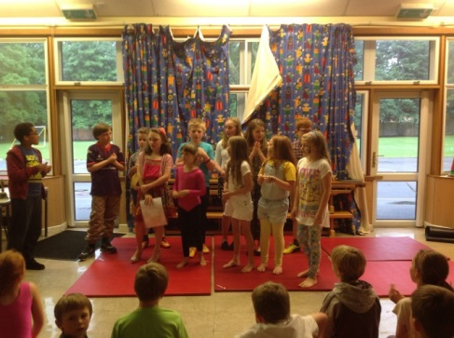

**We look forward to seeing the children back in school on Wednesday September 9th. Have a restful and enjoyable summer holiday!**

Aiskew’s Got Talent

On Wednesday the 8th of July our school held a talent contest. We had acts from singing to dancing to comedy. We all had a fantastic time, including the judges who where played by the Y6s. In the end the winners where Minion Men then the Gymnasticar who came second and then Minty Moo who came third. It was a very successful night and there was a big audience who cheered on everybody.

By Fred and Jessica

bBy

Football Competitions and Matches

During this term we have played some football matches against Burneston. We won one, drew two and lost one. Our goal keepers did a great job which led to four good matches. We have also taken part in a few competitions one at Bedale and one at Thornton Watlass which we all enjoyed aswell.Hopefully the football team next year will have as much fun as we have had.

By George Nicholson & Zoe Farren-Ross.

Sports Day

So we started with the running relay and parents were there too. Then we had a skipping relay, people got caught up in the ropes like Reece. Then we did a football relay we had to dribble the ball round the cones. Last but not least the water race (everyone got drenched) then we had the the year groups race. Finally we had a bucket run all around the pitch. The winning team was green!

By Caden and Reece.

Wills Bros Ltd Poster Competition

Well done to Polly Stones, George Nicholson and Kirsty Bowes who all won prizes in the poster competition run by Wills Bros Ltd. The three children received their prizes from Councillor Carl Les (one of our governors) at a ceremony at Bedale Hall yesterday.