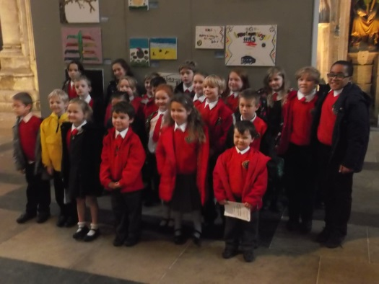

School Closure

As winter approaches we would like to remind you of how to find out about the closure of school. Please tune into either; Radio York – 95.5 FM, 103.9 FM and 104.5 FM or Radio Tees – 95.0 FM who will announce our closure. Alternatively this information will also be available on their websites which are regularly updated - our own website will also have this information from 7.30am. The North Yorkshire County Council website also lists North Yorkshire school closures.

Welcome

We are delighted to welcome Miss Sarah Rawson to our school. Miss Rawson will work as a teaching assistant in Dragons every Monday and she will support Mrs Stones and Mrs Anwar when they provide non-contact time for the classteachers. Miss Rawson is a talented musician with many creative skills so she has much to offer our school. We really hope her time with us is very happy and rewarding.

HMS Heroes Remembrance Service at Ripon Cathedral

On Friday November 6th the HMS Heroes and Eagles went to Ripon Cathedral for a service children’s event. We were on TV, we sang songs and we watched Nepalese dancing. We all made signs or canvases and after the service we went to look at them.

BY ASHLEY AND TOM

Things you didn’t know about Miss Rawson

**What’s your favourite music/band?**

Maroon Five.

**Favourite football team?**

I don’t like football!

**Favourite pizza toppings?** Cheese

**Favourite sport?** Netball

**Favourite subject?** Music/history

**Favourite game?** Munchkin

**Favourite author?** Roald Dahl

**Favourite person?** Ant and Dec

**Favourite TV programme?** Pointless

By Ayden and Aaron

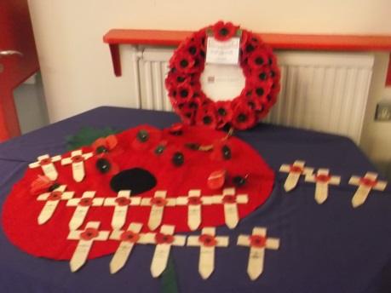

**Family Lunch**

On Wednesday 18th November we held another successful family lunch where 18 family members joined us for lunch.

We will be holding our next family lunch on Wednesday 27th January 2016.

Remembrance Day

Once again we were led so extremely well in our Remembrance worship by a small group of our pupils which included Polly Stones, Kirsty Bowes, Edie Cooper, Emma Barker and Sophie Oliver. The children presented a series of readings, poems and prayers and led us through the remembrance of all the residents of Leeming Bar who died in the wars. The atmosphere was one of reflection and it touched everyone who was there. A big thank you to the children who led our worship and Mrs Millgate who co-ordinated its content and structure.

[](https://www.google.co.uk/url?sa=i&rct=j&q=&esrc=s&source=images&cd=&cad=rja&uact=8&ved=0ahUKEwjIyrvz7Z7JAhUJBBoKHeWSDU4QjRwIBw&url=https://en.wikipedia.org/wiki/Children_in_Need&v6u=https://s-v6exp1-ds.metric.gstatic.com/gen_204?ip%3D37.72.115.78%26ts%3D1448017591317474%26auth%3Dfltf2mim4etj6wntj54dhj5elp5vqrfz%26rndm%3D0.4369507049037215&v6s=2&v6t=5125&bvm=bv.108194040,d.d2s&psig=AFQjCNGWlVlQOrc1WnGj0u9eOoq0_4RQ7A&ust=1448103991259370)

Squash Tournament

On Friday 23rd October

George, Polly, Ashley

and Katie went to a squash

tournament at Bedale squash club. When we arrived, we ended up playing against our friends. George got asked by Diana, our coach, to do a demonstration. At the end, our results were good because we came second overall. We had lots and lots of fun and hope that we get asked again.

By George Nicholson and Polly Stones

**Dates for your Diary**

27 Nov FOALs Christmas Fair 6-7.30pm

2nd Dec Forest Schools afternoon with Burneston

3rd Dec HMS Heroes Cluster meeting 12.30pm

7th Dec Jack & The Beanstalk Pantomime **(please note children will not return to school until 4.30pm)**

10th Dec Christmas Lunch

14th Dec Christmas Production 2.15pm

15th Dec Bears/Dargons Christmas Party pm

17th Dec Eagles Christmas Party pm

17th Dec Christingle Service at St John’s 7pm

18th Dec Achievement Assembly for parents

18th Dec Finish for Christmas **– Children return on Tues 5th Jan**

Website : Calendar

We now have a calendar on our website which is under the ‘Parents tab’. This is updated weekly by Mrs Armstrong informing you of all of our upcoming events in school. Please also refer to our Twitter feed for further details and reminders.

**Congratulations**

**I am really pleased to tell you that Mrs Anwar and Mrs Stones have very recently been awarded with the Higher Level Teaching Assistant Status following eight months of intensive training and assessments. To have two of our teaching assistants with these qualifications is a huge asset to our school. It allows them to teach whole classes and currently pupils are thoroughly enjoying their teaching of PE, RE and PSHE.**

Children in Need was very successful; we raised £106.50! Thank you to all parents for contributing your time for baking the cakes. Thank you also to Mrs Anwar for doing all the reminding. We raised more than expected with the photos, wristbands and cakes. Hopefully everybody enjoyed the day as much as we did.

By Emma Barker and Katie Kettlewell

