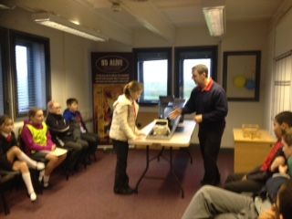[](http://www.google.co.uk/imgres?imgurl=http://images2.sw-cdn.net/model/picture/625x465_144560_106039_1338413386.jpg&imgrefurl=http://www.shapeways.com/model/144560/welcome-goodbye-sign.html&h=465&w=625&tbnid=8BTW4cXuzKIuuM:&zoom=1&q=welcome%20goodbye&docid=5seFFoteF0D-zM&itg=1&hl=en&ei=UsZ9VICGKsTW7AbZwICoBQ&tbm=isch&ved=0CFwQMygxMDE&iact=rc&uact=3&dur=727&page=3&start=48&ndsp=25)

Mrs Stones

Congratulations to Mrs Stones who has recently achieved her CACHE Level 3 Diploma in Specialist Support for Teaching and Learning in Schools. Mrs Stones has worked very hard for this award and it justly recognises her abilities and strengths as a teaching assistant. We are very lucky to have someone with Mrs Stones’ expertise in school and we very much look forward to her continued work and support within our school.

Crucial Crew

On November 21st the Y5/6 pupils went to Crucial Crew to learn about life safety. We brought back lots of knowledge from all the fun activities such as the danger of drinking at a young age, fire safety, car safety, and natural occurring incidence. We all enjoyed our trip and hope everybody else is now aware of how to keep safe and understand the importance of it. The Y3/4 will hopefully have the same amazing experience.

By Isaac Wood and Kirsty Bowes

We are pleased to welcome two new pupils to our school. Danielle Smith (Y5) and Oliver Bennett (Y2) have recently moved to Leeming Bar from Northallerton, and have settled quickly in their new classes. Sadly we are saying goodbye to Sydney Wilton who will be leaving us next Wednesday to move to Cornwall. Sydney has been with us since Y1 and her smiley, cheerful nature will be missed. Good luck Sydney, we wish you every happiness in your new school.

**Changes to Lunch Menu 10.12.14**

The lunch will be Minced Beef & Onion, Parsley potatoes, Carrot & Swede and Rice Pudding & Peaches **not Beef Hotpot.**

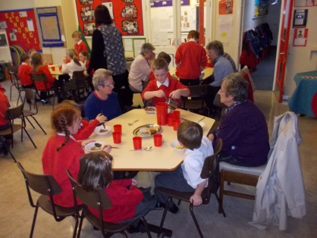

**KS2 Mid-Morning Milk**

Last month we sent a letter out regarding mid-morning milk in KS2. Included in this letter was a reply slip for you to return to school if your child would like to have milk from January 2015.

If your child is in KS2 and would like mid-morning milk but you have not yet returned the form please return **by Friday 12th Dec.**

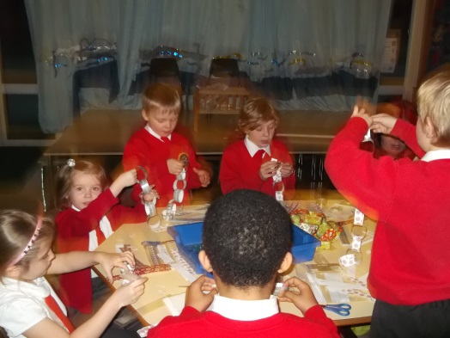

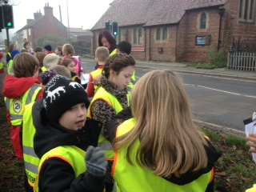

Leeming Bar Walk

On November 25th Eagles went out for the afternoon to look at the different business/industries in Leeming Bar. The reason why we did this is because our school was chosen to take part in an English Heritage project. We talked about John Gills because it used to be an iron foundry. Some of the things they made are still with us today. It was a very enjoyable visit.

By George Nicholson and Thomas Smith

**Dates for family lunches in the Spring Term**

Next term we will be holding 2 family lunches. The dates are: Wednesday 4th February and Friday 6th March. Letters and menus will be sent out in the New Year

Community Lunch

Our community lunch was a very special occasion and it was wonderful to have nine of our neighbours from Leeming Lane sharing lunchtime with our children. They also received a tour of the school and really enjoyed their time with us. One neighbour wrote back and expressed how much she had enjoyed herself and how well the children behaved. We very much hope our community lunch will become a regular event.

Dates for your Diary

Dec 10th – ‘A Christmas Cracker’ production at Burneston am

Dec 11th – Christmas lunch

Dec 12th – Dragons Production Dress Rehearsal 2pm

Dec 17th – Dragons Production 2.30pm

Dec 18th – Christingle Service, St Johns, Leeming 7pm

Dec 19th – Achievement assembly for parents 9.05am

Dec 19th – End of term

HMS Heroes Christmas Craft NightOn Thursday 4th December

we had a Christmas craft night and we made pinecone Christmas decorations for the Christmas tree. We also made Christmas cards and paper chains. It was very successful and 25 people came. We would like to thank Mrs Gray, Mrs Walker and Mrs Swales for helping us in our crafts. We would also like to say a very big thank you to Mrs Stones for organising the whole event. Everyone enjoyed themselves.

By Sydney and Polly